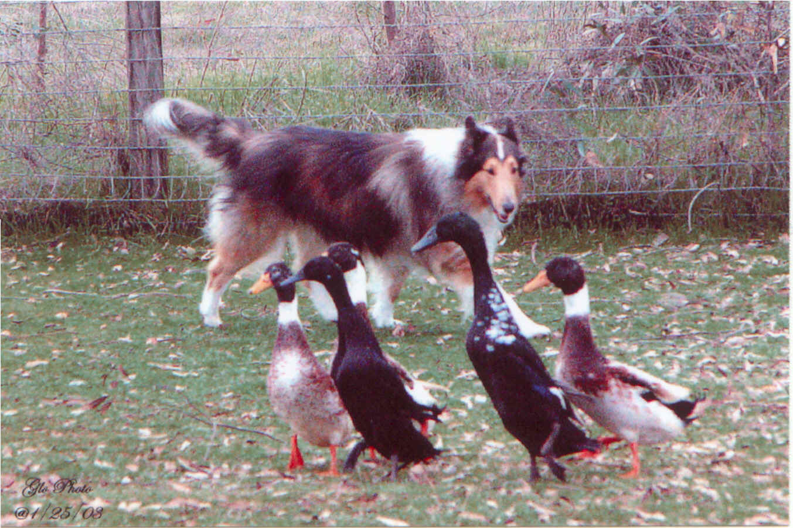
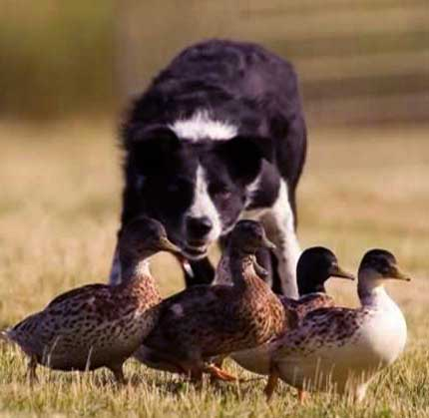
GREAT RIVER STOCK DOG CLUB

WINTER FUNDRAISER
2 DUCK TRIALS
January 24, 2015
Cure the winter blues with fun winter herding in an indoor arena!

NEW LOCATION
Polly Simpson Farm
1479 – 200th Ave.
New Richmond, WI 54017

Entries limited to 20 per trial
$30/first entry each dog
$25/second entry each dog

Trial #1 TIME & OBSTACLE
Trial #2 AHBA
HTAD Course #3 Gather & Shed

Start Time 8:30 am

Potluck lunch & GRSC Annual Meeting
Approx. 11:30 am

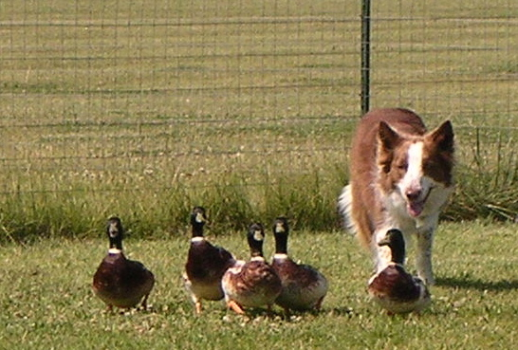
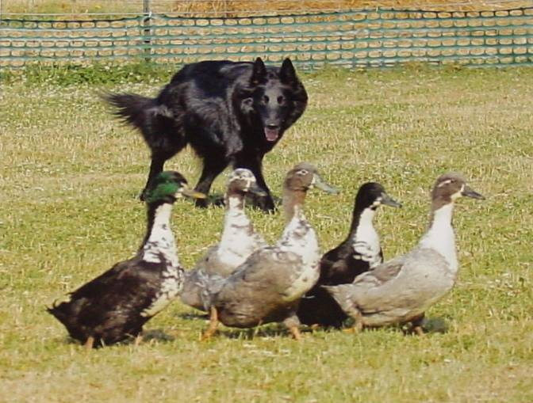
Trial Information&
Entry Forms
joannayund@gmail.com

